Tabish Parkar

Formative Assessment 1: Systems Development 1 (HSYD100-1)

1.1. Class – Car.

Objects – Doors, sunroof, semi-bullet proof windows and six wheels.

Method – The ability to go into sports mode.

1.2. Polymorphism is the ability to change the attributes of an object for example a car can be changed from eco mode to sport plus mode with a press of a button telling the engine control unit to release the engines full potential for the driver to use. The driver can then revert to eco mode to save fuel which is another form of polymorphism.

1.3. Developers use information hiding by encapsulation. Encapsulation is used in Object Orientated Programming to hide how specific methods work because it is not necessary to have more information about the method which would make the code more complex.

2.1. It refers to the availability of a variable within a block of code.

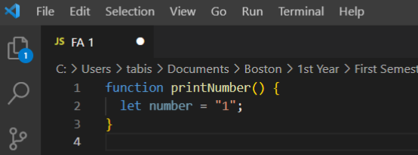

In the example above there is nothing in the block of code which will lead to an error.

2.2. This would be called concatenation. 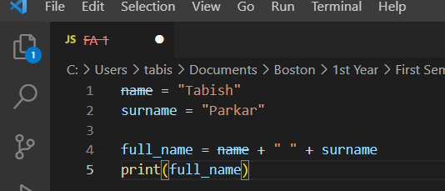

2.3. Operator precedence is when a math sum is calculated in an ordered way like the BODMAS method. Multiplication, division and remainder operators have an equal precedence compared to addition and subtraction which have a lower precedence.

In this case the sum inside the bracket would be given precedence first. Then the sum of 7 \* 2 inside the second bracket which would equal 14. The original bracket remains with the sum now showing 4 \* (5 +14). 5 + 14 = 19.

Lastly, we multiply 4 \* 19 which will yield us with the final answer of 76.

2.4. A named constant which can also be called a symbolic constant, is similar to a variable in the way that it has a name, data type and a value. A literal constant is when the value is taken literally. A numeric constant is in opposition to the character or string constant, it displays values.

3.1. When a return statement is embedded in the method, when an exception is put in a method and is not found inside the method and when a programmer codes a conditional statement which will terminate depending on the conditions.

3.2. Overloading is a method which gives you the ability to use one identifier to execute various objectives, to be more precise it means to write multiple methods in the same scope that has the same name but different parameter lists. When various methods share a name, the compiler will understand which one to use dependent on the arguments in the methods call.

3.3. The section where the data items scope is visible to a program and it can also be referred to by using its simple identifier. A variable will be in scope from when it is stated lasting till the ending of the block of code within where the declaration lies.

3.4. Java method headers must contain a return type, an identifier, optional access specifiers, parentheses which may or may not be empty and an optional static modifier.

4.1. The beginning of the main method.

4.2. Creates a scanner where a user can input characters.

4.3. User must enter their first name which will be assigned to the string.

4.4. Shows a greeting using the users first name. There is also a parameter.

4.5. Variables

4.6. F

4.7. There is no return value.

4.8. Void return type

4.9. Shows a string which will include the first name of the user along with the greeting in line G

5.